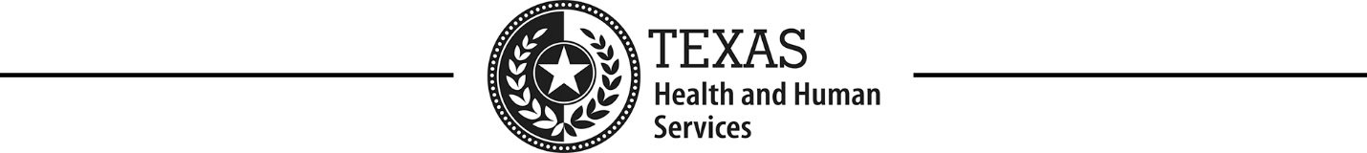

Accessibility Severity Classification

Severity One
The standards compliance defect is sufficient that someone with a disability will be prevented from accessing critical information or functionality.

Severity Two
The standards compliance defect is sufficient that someone with a disability will be prevented from accessing critical information or functionality but there is a known work-around.

Severity Three
The standards compliance defect does not impact access to critical functionality or information but may prevent access to non-critical information or functionality.

Severity Four
The standards compliance defect only impacts the ease of use of the product but not access to any functionality or information.

