How to Make Lists Accessible in MS Word
This exercise is designed to show why you should use lists in your document.

Lists Add Structure and Meaning To A Document
Like headings, lists add STRUCTURE and MEANING to a page and allow both users who are sighted and visually impaired (blind, low vision) to quickly navigate through a “list” of items. There are two major types of list in MS Word. Bullet list (similar to unordered list tag <ol> in HTML) and number list (similar to ordered list tag <ul> in HTML). Best practice is to use a number list when the order of sequence in the list is important, otherwise; you can use a bullet list.

Benefits of Using Lists
For users who are visually impaired: Screen readers use lists to compile a complete “list of lists” (INSERT+F3 in a PDF or HTML document. INSERT+F3 in MS Word will show the JAWS Find dialog box) on a page so that users who are visually impaired can easily navigate to a particular list without having the whole page read to them by a screen reader. Moreover, JAWS will announce that a list is coming (for example, “a list of four bullets”) and ending (for example, "list end").
For users who are sighted: If there is a series of related items, sighted readers as well as visually impaired readers understand and recall information better if items are placed in a list than if the same information was presented in a sentence format.
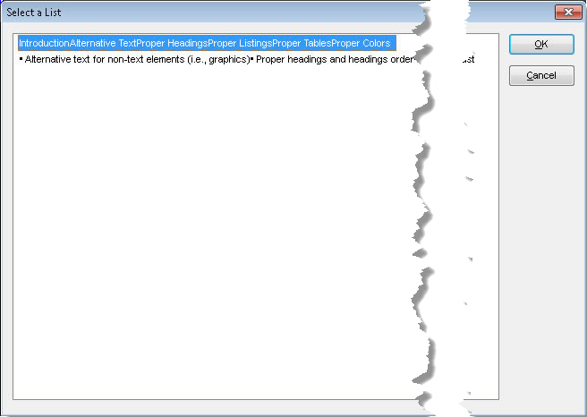
Figure 1: Select a List dialog box in JAWS showing a list of lists

ADDITIONAL NOTES:
- Like headings, while not as important, if possible keep list items short because long list items make it harder to scan a page quickly.
- Properly nest lists within other lists. Better yet, break complex nested lists into simple lists.

Steps in making an accessible list:
- Select the paragraphs below.
- Click the bullet or number icon to convert the paragraphs to a bullet or number list, respectively.
- Select the second and third bullet items and then click the Increase Indent from the Ribbon. This will create a list-in-a-list.
DADS—Department of Aging and Disability Services
DBS—Division for Blind Services
DFPS—Department of Family and Protective Services
DSHS—Department of State Health Services
HHS—Health and Human Services
CAUTION: If you want to add or remove spaces between list items, use the Line and Paragraph Spacing in the Ribbon. Otherwise, you may corrupt the list for a screen reader.
